from keras.models import Sequential

from keras.layers import Dense

from keras.callbacks import EarlyStopping

from sklearn.preprocessing import StandardScaler

from sklearn.model_selection import train_test_split

import pandas as pd

df = pd.read_csv('insurance.csv')

df.head()

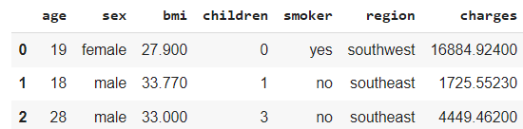

**df = pd.get_dummies(df, columns=['sex','smoker','region'], drop_first=True)**

**df.head()**

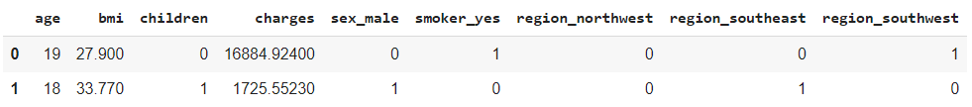

X_cols = list(set(df.columns)-set(['charges']))

y_col = ['charges']

X = df[X_cols].values

y = df[y_col].values

X_train, X_test, y_train, y_test = train_test_split(X,y)

sc_x = StandardScaler().fit(X)

X_train = sc_x.transform(X_train)

X_test = sc_x.transform(X_test)

sc_y = StandardScaler().fit(y)

y_train = sc_y.transform(y_train)

y_test = sc_y.transform(y_test)

model=Sequential([

         Dense(128,input_dim=X_train.shape[1], activation='relu'),

         Dense(32,activation='relu'),

         Dense(1)

  ])

model.compile(optimizer='adam',loss='mse')

early=EarlyStopping(monitor='val_loss', patience=10)

epocas=400

history=model.fit(X_train,y_train,epochs=epocas,validation_split=0.25,callbacks=[early])

pd.DataFrame(history.history).plot();

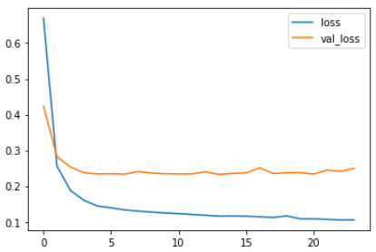

y_test y X_test tienen shape (335, 8)

from sklearn.metrics import r2_score

print("R2 ",r2_score(y_test,model.predict(X_test)).round(3))

R2 0.837

MEJOR PREDICCION

PREDECIR….

model.predict(X_test)

p0= X_test[0]

p1= X_test[1]

import numpy as np

arr = np.vstack([p0,p1])

model.predict(arr)

PARA 1 PUNTO

p1= X_test[1]

q = model.predict( np.array( [p1,] )  )

q